General Information

Registration
Participants are encouraged to register on line with full payment to JKA/AF, at https://bit.ly/3vECVGb. Mailed registration forms will also be accepted.

Please make US certified checks or money orders payable to JKA/AF. Pay via PayPal at: paypal.me/lakarate. Payment by credit card is also available with an additional charge of 4% to cover credit card fees.

Registration is to be completed by June 2, 2021. Registration at the door will incur $50.00 additional processing fee per entry. This means camp will be $200.00 at the door. No discounts will apply at the door registration.

Information
E-mail for Camp contact jkattawar@live.com.

Dan and Qualifications Examinations
Registrants must contact Jerry Kattawar and send in testing forms to: Jerry Kattawar @live.com before applying for the Dan and Qualifications Examinations, which must also be submitted by May 21, 2021.

Purpose
The camp is designed to standardize and improve technical level of karate worldwide under the guidance of JKA HQ standards.

Host
JKA American Federation

Eligibility
A minimum of three months of training is required.
Dan and Qualification examinees must attend the full camp to test.

SEMINAR CONTENT
- General instruction
- Seminar for Judges
- Dan examinations
- Only camp participants are eligible for examinations
- Examinees must have: JKA passport and copies of previous Dan Exam certificates
- Examinees who are transferring from another organization must inform registration representative prior to attending the camp
- Examinees must meet the minimum time frame requirement between exams as stipulated by JKA HQ

EXAMINATION FEES.
Rank | Examination Fee | Registration Fee
1st Dan | $80 US | $ 130US
2ndDan | $100 US | $ 170US
3rd Dan | $120 US | $ 225US
4th Dan | $150 US | $ 270US
5th Dan | $200 US | $ 550US

QUALIFICATION EXAM FEES.
Level | Examination Fee | Registration Fee
Instructor D Kyu | $80 US | $ 100US
Examiner D Kyu | $80 US | $ 150US
Judge D Kyu | $70 US | $ 100US
All renewal fees |  | $ 100US

DAN EXAMINATION INFORMATION
Please refer to the JKA website for the most current Dan and license examination qualification requirements:
https://www.jka.or.jp/en/about-jka/qualification/

*All JKA members testing for Dan Exams should present current passport upon registration
** If you fail a test, the registration portion will be refunded

PARTICIPANT’S MEDICAL QUESTIONNAIRE:
To be completed by all adults and guardians of minors attending the 2021 JKA AF Summer Festival.
Name___________________________________________ Date of Birth__________________ Sex_______ Rank_______
Address______________________________________________________ City _____________ State_____ Zip________
Organization__________________ Country __________________________ Dojo ______________________________
Do you have a history of any of the following conditions? Please check either yes or no for each one.
If you answer yes to any, please explain:
Yes No
___ ___ Have you tested positive for Covid-19 within the last fourteen days?
___ ___ Heart murmur
___ ___ Hypertension
___ ___ Recent infection
___ ___ Bone fracture in the past six months
___ ___ Concussion or severe head injury in the past six months
___ ___ Seizures
___ ___ Eye injury
___ ___ Severe bone bruises requiring padding
___ ___ Kidney injury
___ ___ Allergy to medication (list all):
___ ___ Are you currently taking any medications? If yes please specify _____________________________
___ ___ Other:_______________________________________________________________________________________

___________________________________________________________________ Date _______________________
Signature of Participant (Parent or Guardian if under 18 years of age)

WAIVER/RELEASE AGREEMENT: Event: the JKAAF Summer Festival 2021. I understand that there are risks and dangers inherent in martial arts training and in participating in and/or receiving instruction at the EVENT. I understand and agree that by signing this Waiver/Release, I am assuming full responsibility for any and all risk of personal injury or death or for property damage suffered by me while participating in and/or receiving instruction at the EVENT. I expressly acknowledge that my participation in the EVENT June 3-6, 2021 subject me to personal injury or bodily harm and I assume any and all risks of that participation, including the risk of contracting communicable diseases such as Covid-19. I also understand that in order to be allowed to participate in and/or receive instruction at the EVENT, I must give up my rights to hold the JKA American Federation and its affiliates, All South Karate Federation , the Grace King High School, and any and all other clubs, schools, instructors, members, judges, officials, representatives and all other participants (collectively the “Releasees”) liable for any injury or damage which I may suffer while participating in and/or receiving instruction at the EVENT.

I also understand and agree that by signing the Waiver/Release, I acknowledge that I am solely responsible for having or obtaining all insurance coverage which may be necessary or desirable in connection with my participation in and/or receipt of instruction at the EVENT and for any travel to and from the EVENT and in all lodging or any other activities which may be related directly, indirectly or incidentally to the foregoing. I further understand and agree that any fees or costs required for necessary or requested medical attention shall be my sole responsibility and that I shall not seek indemnification or contribution from any Releasee in connection therewith. I also understand that the Releasees shall not be responsible for any incidental, consequential or exemplary damages of any kind even if they are notified of the possibility of such in advance. I also understand and agree that any damage to any lodging sites or the tournament site that I cause is my full responsibility. In no case are said damages the responsibility of any of the Releasees. I further understand and agree that as consideration for my participation in the EVENT, the JKA American Federation and /or its designees shall have the right to use my name, image or likeness in the promotion of the EVENT or in any publication relating to the EVENT (or similar Events) and in any broadcast or rebroadcast transmission of the EVENT without any additional consideration to me for the use of my said name, image, audio/sound or likeness.

I understand and agree that this Waiver/Release will have the effect of releasing, discharging, waiving and forever relinquishing any and all actions or causes of action that I have or have had, whether past, present or future, whether known or unknown, and whether anticipated or unanticipated by me, arising out of my participation in and/or receipt of instruction at the EVENT. Knowing this, and in consideration of being permitted to participate in and/or receive instruction at the EVENT, I hereby release and agree to indemnify and hold harmless the above-named Releasees individually and their entities, and their officers, agents, principals, partners, shareholders, directors and employees from any and all liability or costs, including attorney fees, associated with or arising from my participation in and/or receipt of instruction at the EVENT. I further understand and agree that this Waiver/Release will be binding on me, my spouse, my heirs, my personal representative, my assigns, my children, and any guardian ad litem for said children.

I understand that if I am signing this Waiver/Release on behalf of my minor child, that I will be giving up the same rights for said minor as I would be giving up if I signed this document on my own behalf. I acknowledge that I have read this Waiver/Release Agreement and that I understand the words and language in it.

Print Name___________________________________________________ Date____________________

Sign Name_______________________________________________Witness_____________________________________________
THIS FORM IS FOR MINOR PARTICIPANTS AND MUST BE FILLED OUT BY PARENT OR LEGAL GUARDIAN. PLEASE PRINT CLEARLY. ALL INFORMATION MUST BE SUPPLIED.

EMERGENCY CONTACT AND MEDICAL INFORMATION:
Name of Parent/Legal Guardian: _______________________________________________________________________________

Address:_____________________________________________________ City_________________ State______ Zip___________

Telephone ___________________(day) __________________(night) Child’s Name:_____________________________________

Any recent or present condition or injury: ________________________________________________________________________

My child is allergic to the following medications: ___________________________________________________________________

My child routinely takes the following medication: __________________________________________________________________

Her/his last tetanus immunization was: __________________________________________________________________________

CONSENT FOR EMERGENCY TREATMENT:
Date: _____/_____ /_____
I hereby give permission to the Emergency Department at any hospital chosen or designated by the JKA American Federation to treat my son/daughter (name of minor):

Last Name ___________________________________________ First Name ____________________________________________
while we are away. I understand this permission covers the average emergency such as strain, sprain, cut, bruise, scrape, bump, skin rash such as impetigo, poison oak or ivy, bites such as bee stings and snake bites, allergic reactions, foreign bodies in the eye or skin, upset stomach, diarrhea, pink eye, minor burns, sunburn, suspected minor fractures, minor concussions, fevers, diagnostic x-rays, suturing, and the like. I give permission for my child to receive a tetanus booster (if needed). This permission is valid for 6 months only. I also understand that in cases of major significance such as a fracture, appendicitis, or any illness or injury requiring admission that additional consents will be necessary for treatment and that the hospital will make every attempt to reach me. I can be reached at the above address. Authorization is hereby given to release to:

_____________________________________________________ ____________________________________________________
(Insurance company) (Policy number)
any information needed to complete hospitalization claims. Finally, I understand in cases of acute emergency when hospital personnel have attempted to notify me and are unable to reach me, that this permission form will suffice for treatment until such time as I am able to be reached. While we are away, (name of minor):

Last Name ___________________________________________ First Name ____________________________________________
is under care of: JKA American Federation

This form is for minor participants and must be filled out by Parent or Legal Guardian. Please print clearly. All information must be supplied.
JKA American Federation/ All South Karate Federation PARENTAL CONSENT FORM:

First Aid
I hereby give permission for JKA American Federation / All South Karate Federation (hereinafter “JKAAF/ASKF) doctor
or nurse to administer minor first aid and/or seek emergency medical care for my son/daughter (name of minor):

Last Name ___________________________________________ First Name ____________________________________________
during his/her stay at the JKAAF Summer Festival 2021, being held at Grace King High School, New Orleans, Louisiana, June 3-6, 2021. I understand that this permission covers the average emergency such as, but not limited to, strains, sprains, cuts, bruises, scrapes, bumps, skin rashes, minor bites, allergic reactions, upset stomach, diarrhea, minor burns, suspected minor fractures, fevers, and other similar occurrences. This permission is valid only for the duration of the JKAAF/ASKF event or activity described above.
Emergency Care
In the event that my child needs emergency medical care, as determined by the JKAAF/ASKF doctor/nurse, supervisory staff or administrators, I hereby give permission for said child to be treated in the emergency room and by the medical professionals of the hospital or medical center nearest to or most easily accessible to the JKAAF/ASKF event or activity described above. This permission includes, but is not limited to, fractures, snake bites, allergic reactions, minor concussions, contusions, lacerations, foreign bodies in the eyes or skin, fevers, diagnostic x-rays, suturing, minor burns, etc. I also give permission for my child to receive a tetanus booster (if needed). I understand that in cases of major significance, such as a fracture, appendicitis, or any illness or injury which would require admission to a hospital, more consents will be necessary for treatment. If such a situation should arise, I further understand that the JKAAF/ASKF doctor/nurse, supervisory staff and/or administrators, and the hospital will make every attempt to reach me. I hereby release JKAAF Summer Festival 2021 (JKA American Federation Summer Festival, JKAAF/ASKF and Grace King High School from any and all liabilities due to personal injury, bodily harm, or lost or stolen articles.

___________________________________
Signature of Parent/Legal Guardian
Examiner’s Record

Rank Being Tested for
Dan
Authorization To Take Examination

Stamp
Examination Fee
Registration Fee

Name

Karate Organization

No.

Date of Examination
Year Month Day

Sign this slip and hand it in within THREE (3) months to receive “Dan” certificate or in case of failure, to receive refund of registration fee.

Ranking Information
Rank Being Tested for

Present Rank
Kyu Dan
Date of Conferral
Year Month Day

Dan Kyu
Registration No.

Number of Months and Years in Karate Training
Years Months

Present Qualifications

Instructor
Examiner
Judge
Class
Class
Class
Karate Organization

Membership Number

Height
cm
Weight
kg
Date Year Month Day
Name
Sex
Male Female
Date of Examination
Year Month Day
Age

Date of Birth
Year Month Day
Nationality

Present Address
Tel.

Last Academic School Attended

Reference
Name
Address

Relationship

Tel.

Remark

Examination Fee

Pass

Fail

Re-exam

Pending
Basic
Kata
Kumite
Application of Techniques
Research
Others
Total Marks
Results
A
B
Chief Examiner Signature
Scoring

Registration Fee

Japan Karate Association
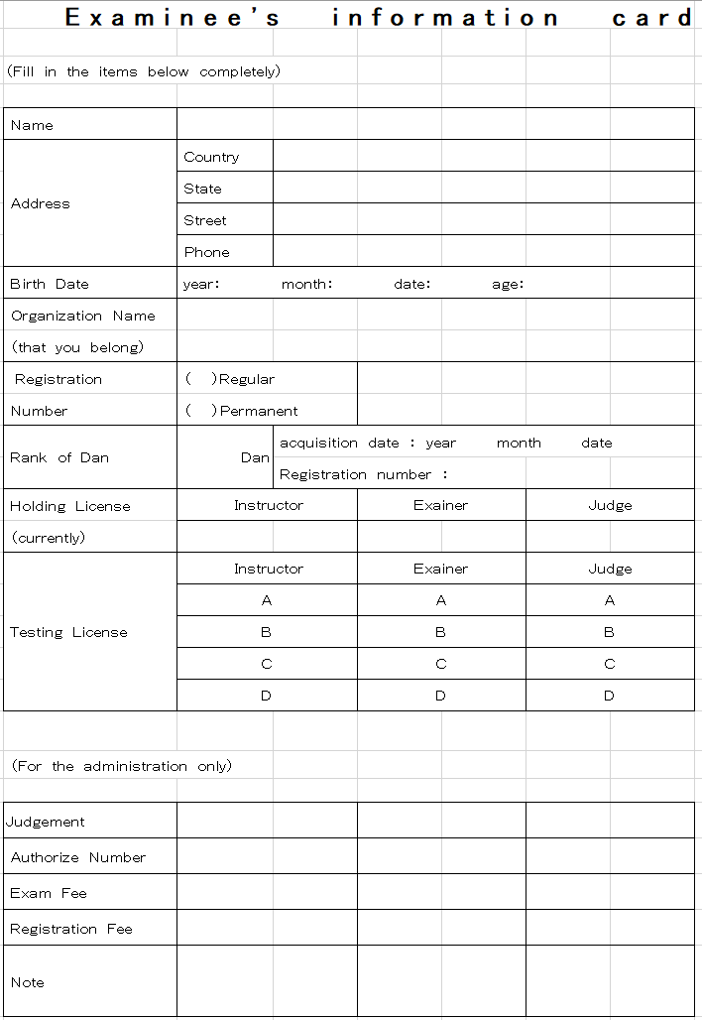

JKA AMERICAN FEDERATION
706-C Phosphor Avenue
Metairie, LA 70005
Phone 985-951-0577 - Email: jkattawar@live.com
www.jkaaf.org

2021 JKA American Federation Summer Festival Registration Form

Name: ___________________________________________ Age: ________ Male / Female(Circle one) Address:
Phone#: , e-mail address: ________________________________________
Present Dan: Dan
Camp Participation Fee (Tournament included) $___________________
$150 US for entire camp (regardless of the number of sessions)
$125 Second Family Member
$125 Camp fee if you are testing
$50 fee if you register at the door

Children under 13 years old $100 $____________________

Dan Exam fee (see chart) $____________________

Dan Registration (see chart) $____________________

Qualification Exams: Instructor – Examiner – Judge (circle)
(see chart) $_____________________

Qualifications Registration: (see chart) $___________________

Zoom Class ($150) $__________________

T-shirt ($20) SIZE:: _________ $ ___________________

TOTAL $____________________

Please fill in this form and return it to the address for JKA American Federation.

Cash, Certified Check or Money Order is due upon check-in or mail ahead of time. Pay via paypal at paypal.me/lakarate. Credit Card option is also available. Credit card payments will have an additional fee of 4% to cover processing costs. Make payments to: JKA American Federation Make sure you mail your payment with enough time to be received before the first day of camp.

Please use the following mailing address for payment and registration:

JKA AMERICAN FEDERATION
706-C Phosphor Avenue
Metairie, LA 70005

Or register ONLINE AT https://bit.ly/3vECVGb

JAPAN KARATE ASSOCIATION AMERICAN FEDERATION
Summer Festival
June 3-6 ,2021

Date |  | Time | Location | Instructor/Guest |  |  | Training
Wednesday |  | 5:30 p.m- 7:30 p.m. | LKA Dojo | Sensei Jerry Kattawar Jr |  |  | Kihon Basic Training
Guest of LKA |  |  | LKA Dojo | Sensei Takayuki Mikami |  |  | Advanced Training
Thursday |  | 8:00 a.m.-10:00 a.m. | Grace King | Sensei Takayuki Mikami |  |  | Basic Training
 |  | (unofficial registration) |  | Sensei Fathi Jarushi |  |  | Kata - Jion
 |  | 1:00 p.m - 3:00 p.m. | GK - Classroom | Sensei John Haral |  |  | Basic Training
 |  |  |  | Sensei Scott Decuir |  |  | Heian/ Tekki Kata
 |  | (unofficial registration)
 |  | 4:30 p.m.- 6:30 p.m. | Gk- classroom | Sensei Andre Fiallos |  |  | Kata- Sochin
 |  | (unofficial registration) |  | Sensei Kyriakos Papadopoulos |  |  | Kata- Bassai Sho
Friday |  | 8:00 a.m.-10:00 a.m. | Grace King | Sensei Takayuki Mikami |  |  | Advanced Training
 |  | Final Registration (7-8) |  | Sensei Wauriman Borges |  |  | Kumite Techniques
 |  | 10:00 | Grace King | Written testing for license
 |  | 11:30 p.m - 1:00 p.m. | Grace King | Sensei Joey Giluso |  |  | Advanced Training
 |  |  |  | Sensei Natsumi Sugiyama |  |  | Yoga/Self Defense
 |  | 2:30 p.m.- 4:30 p.m. | Grace King | Sensei Kyriakos Papadopoulos |  |  | Kata – Gojushiho-dai
 |  |  |  | Sensei Rachel Kattawar |  |  | Balance and Stability through transition
 |  | 5:00p.m.-8:00 p.m. |  | Dan / License Testing
Saturday |  | 8:00 a.m.-10:00 a.m. | Grace King | Sensei Takayuki Mikami |  |  | Advanced Training
 |  |  |  | Sensei Dimitri Papadopoulos |  |  | Kata- Kanku Sho
 |  | 10:30 p.m-1:00 p.m. | Grace King | Tournament (Kata, Kumite persons must be vaccinated due to traveling)
 |  | 4:00 p:m- 4:55 p.m. | Grace King. | Sensei Lane Nevils |  |  | Advanced Training
 |  | 5:00 p.m.- 6:00 p.m. | Grace King | JKA Instructor (ZOOM) |  |  | Kata
 |  | 7:30 p.m. | Kyoto 2 | Get Together - Dinner
Sunday |  | 8:00 a.m.-10:00 a.m. | Grace King | Sensei Takayuki Mikami |  |  | Review Training
 |  |  |  | Sensei Fathi Jarushi |  |  | Review Training

